Aluminum Reaction with Copper (II) chloride Reaction 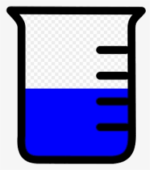
Purpose: To observe chemical changes when aluminum and copper (II) chloride (CuCl₂) and water react. To be able to describe the chemical changes.
Materials:
Safety goggles 100 mL beaker
CuCl₂ water
Aluminum foil Stirring rod
Thermometer Paper towel
Procedure:
- Wear safety goggles at all times.

- Measure 50 mL of water in the beaker. Record the temperature of the water (in degrees Celsius).

- Get a pre-measured amount of CuCl₂ (about 2 g). Be careful not get any of the CuCl₂ on your hands.

- Carefully add the CuCl₂ to the water. Do not stir. Describe what you observe.

- Record the temperature of the CuCl₂ solution.

- Stir the CuCl₂ until it is completely dissolved.
- Make the aluminum foil into a loose ball and using the stirring rod, hold it under the liquid in the beaker. Record the temperature and draw and record all the chemical changes that you observe.

Conclusion (how did you know that there were chemical changes when Al, water and CuCl₂ were combined?):

